**Computer Programming Methodology assignment.**

**Group Members.**

1. Erick Katana - BSCAS/2020/92094
2. Alex Mahenzo - BSCAS/2020/90896
3. Patrick Njoroge - BSCAS/2020/90137
4. Thomas Musyoka - BSCAS/2020/90673
5. Caleb Kirui - BSCAS/2020/89905
6. Steven Omondi - BSCAS/2020/68988
7. Kelvin Munene - BSCAS/2020/91866
8. Wendy Oduor - BSCAS/2020/91790
9. Mohamed Ibrahim - BSCAS/2020/91632
10. Shadrack Cheruiyot – BSCAS/2020/91253
11. Dennis Maigwa - BSCAS/2020/89527

3. **Program Structure**

**Example**

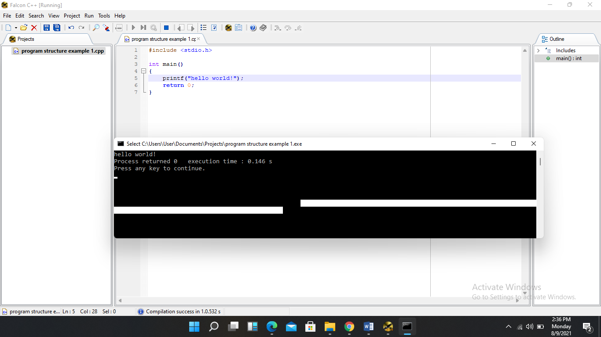

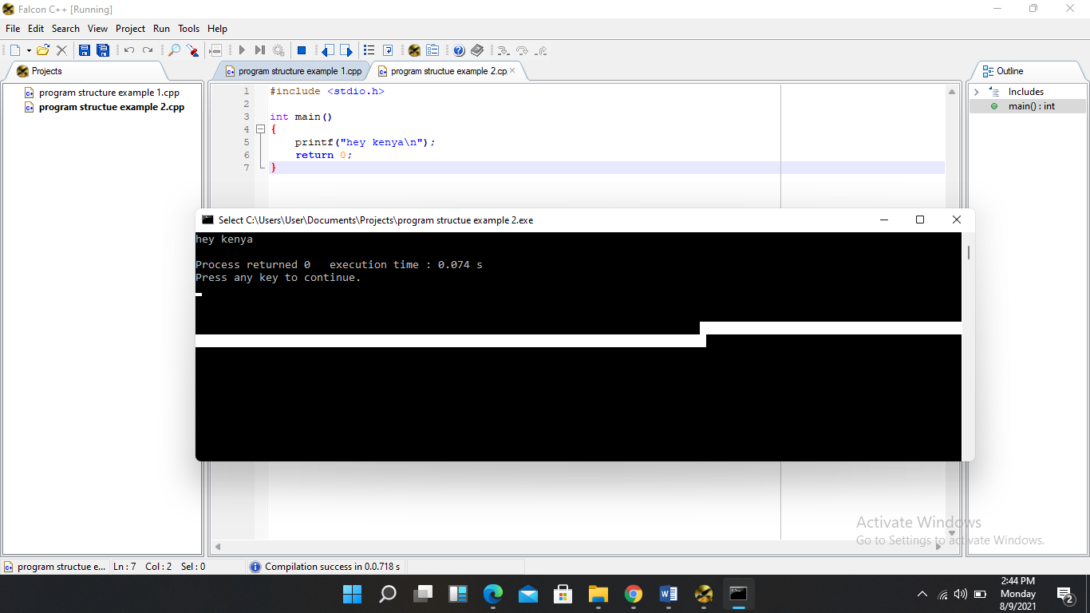

**4. Basic syntax.**

**Examples**

**5.** **Data types**

**Examples**

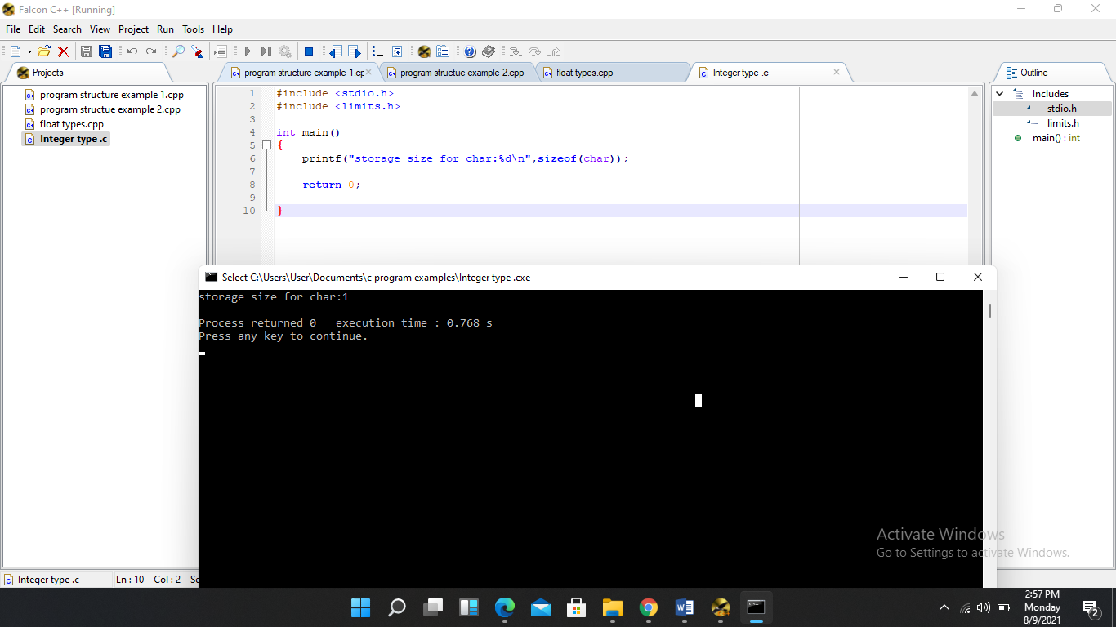

Float types

Examples 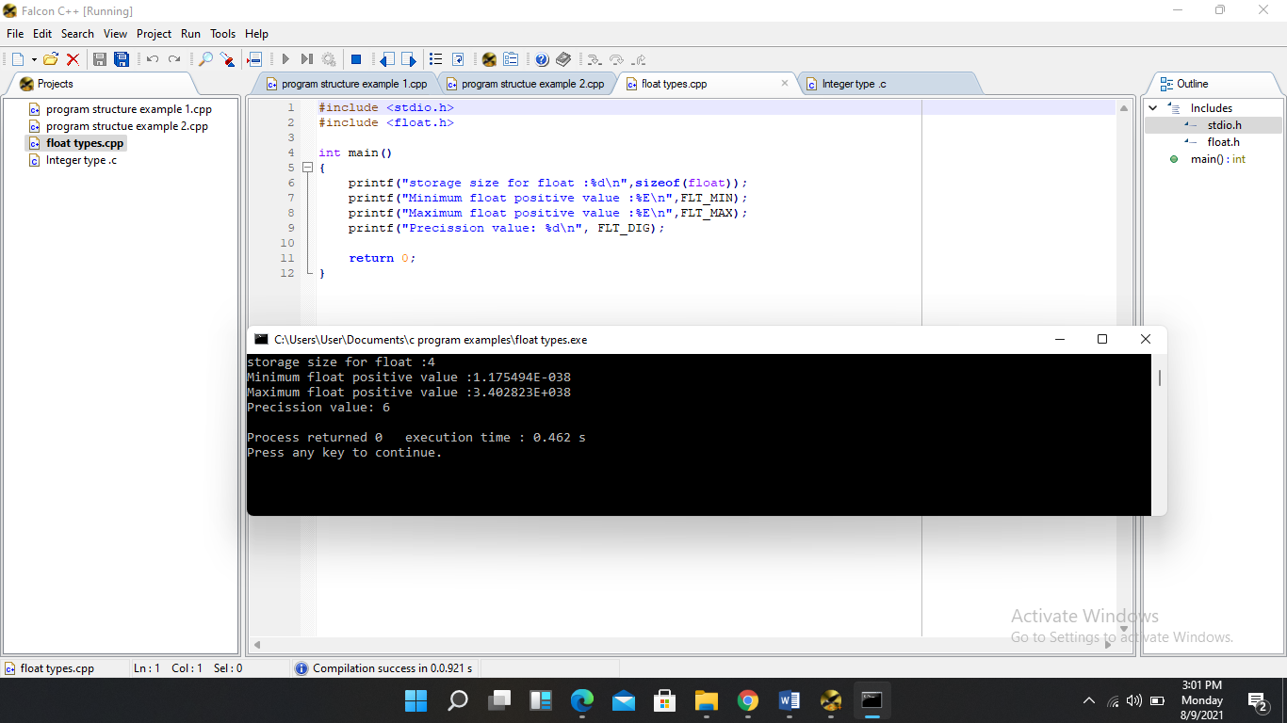

**6.Variable declaration**

**Examples**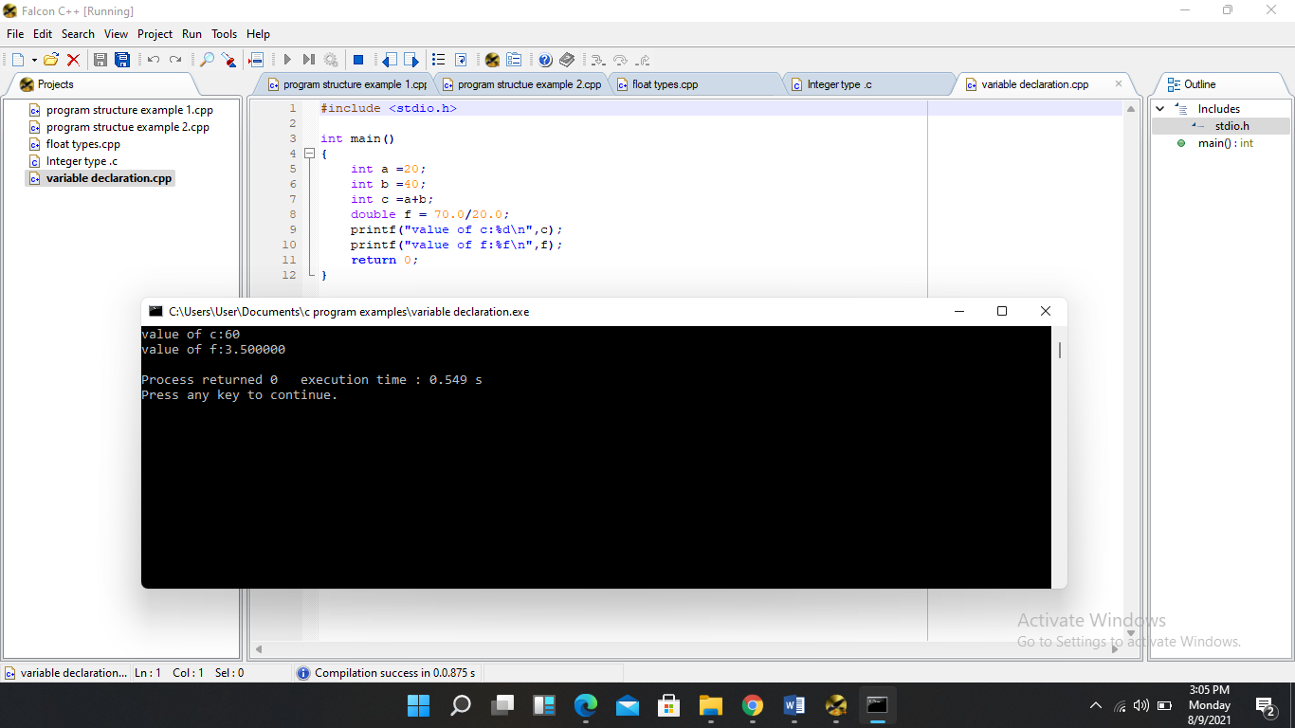

**7. Constants and literals**

#define preprocessor example

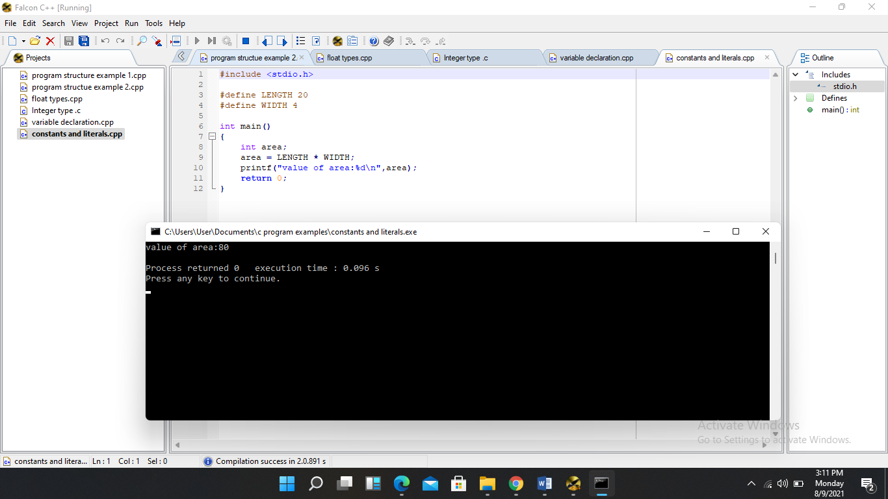

Const keyword

Example

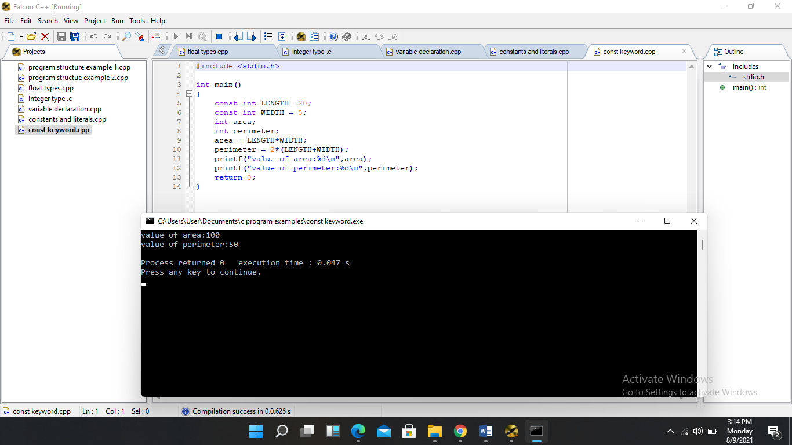

**8. Storage classes**

**Examples**

Static storage class 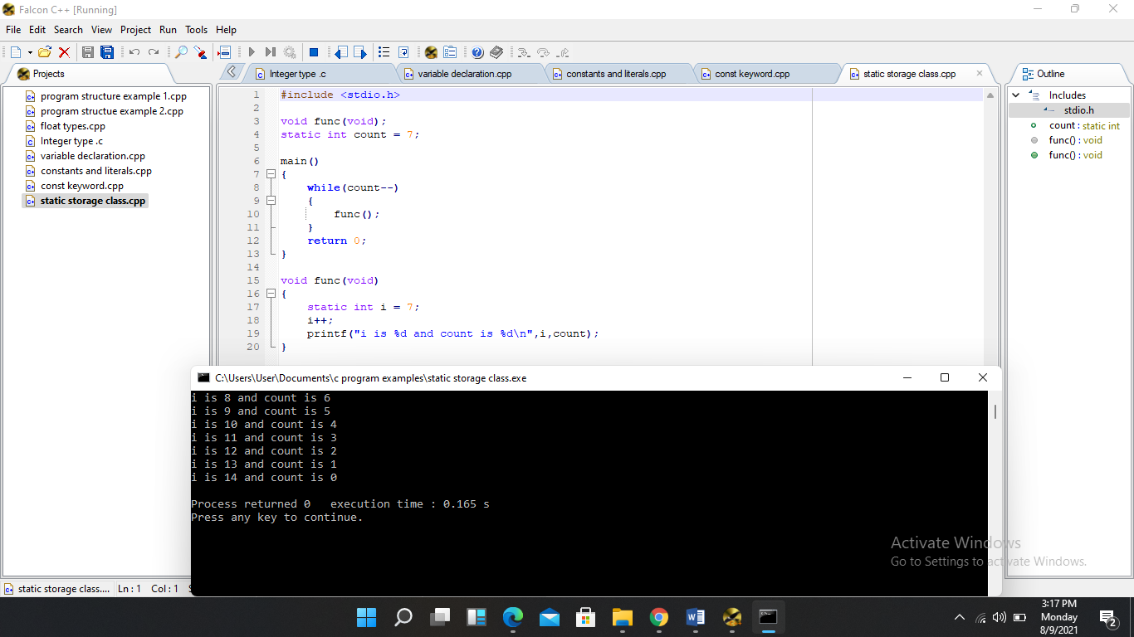

Extern storage

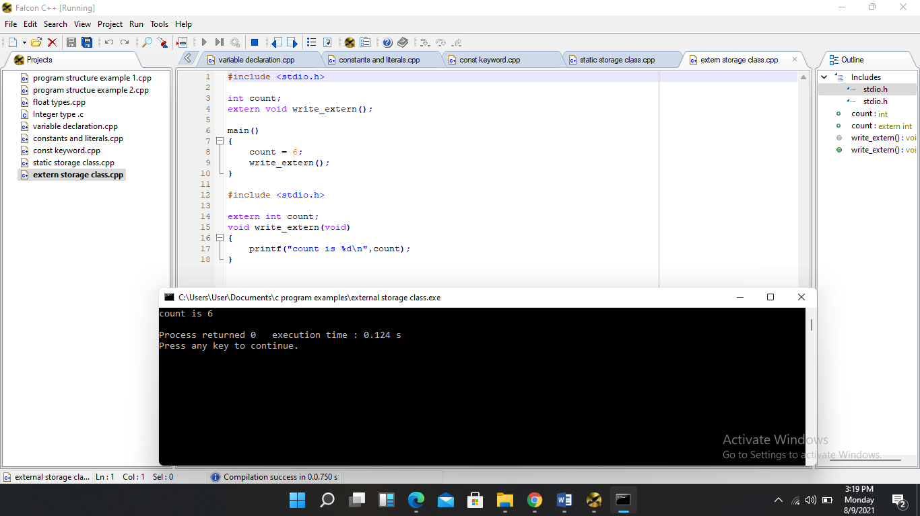

**9.** **Operators**

**Examples**

Arithmetic Operators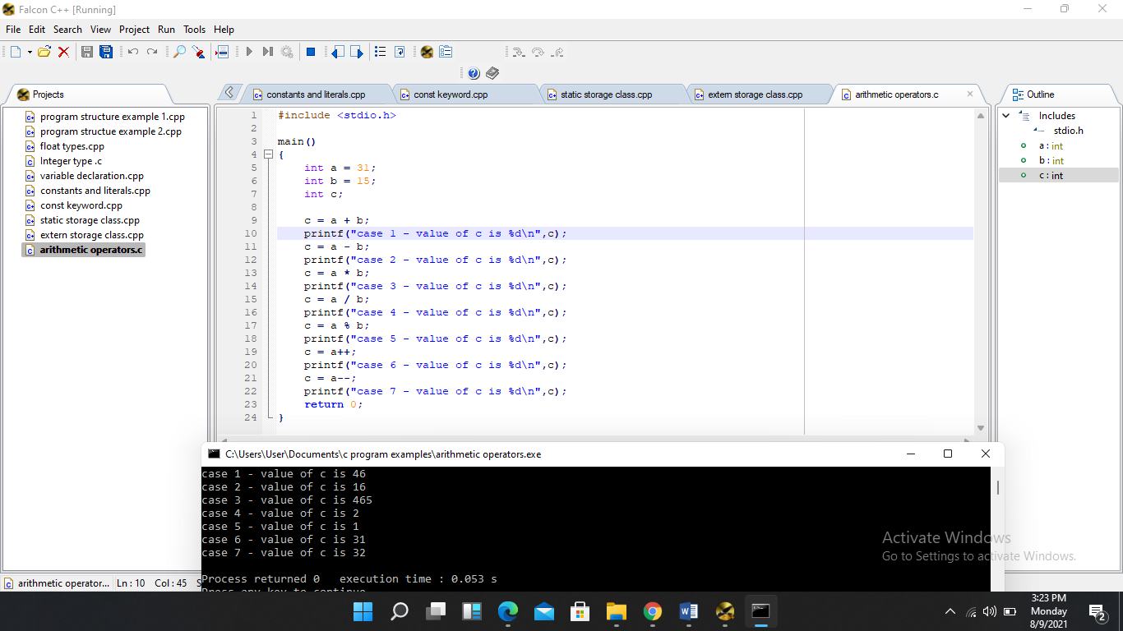

Relational Operators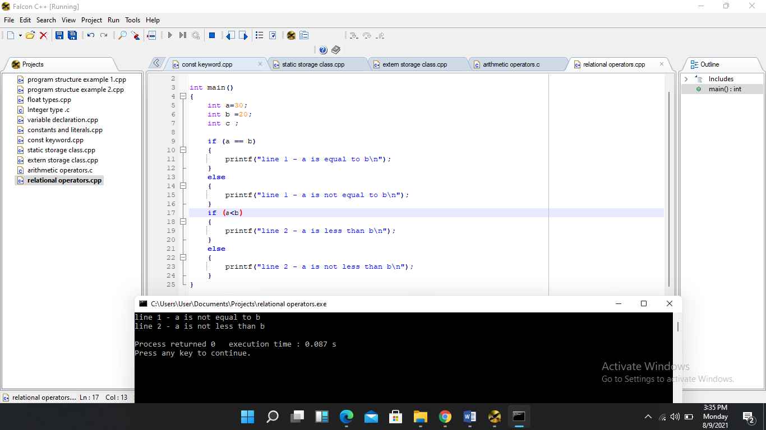

Logical operators

Example

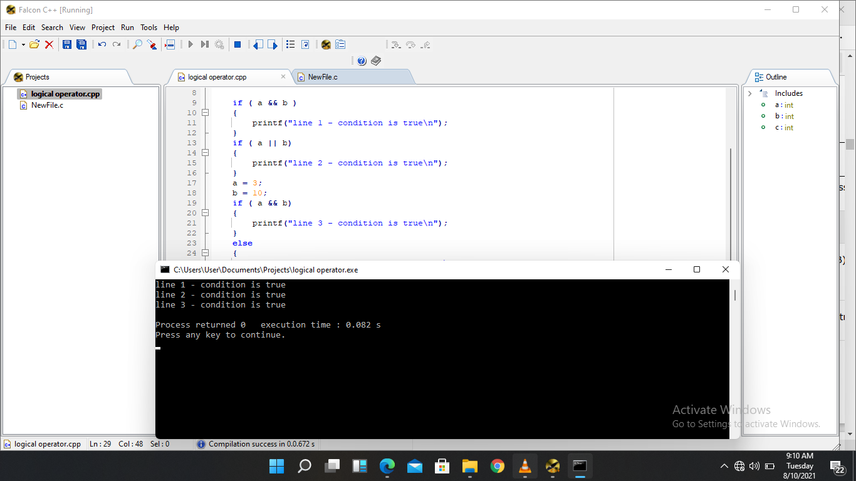

**10.Decision making**

**Examples**

If Statement

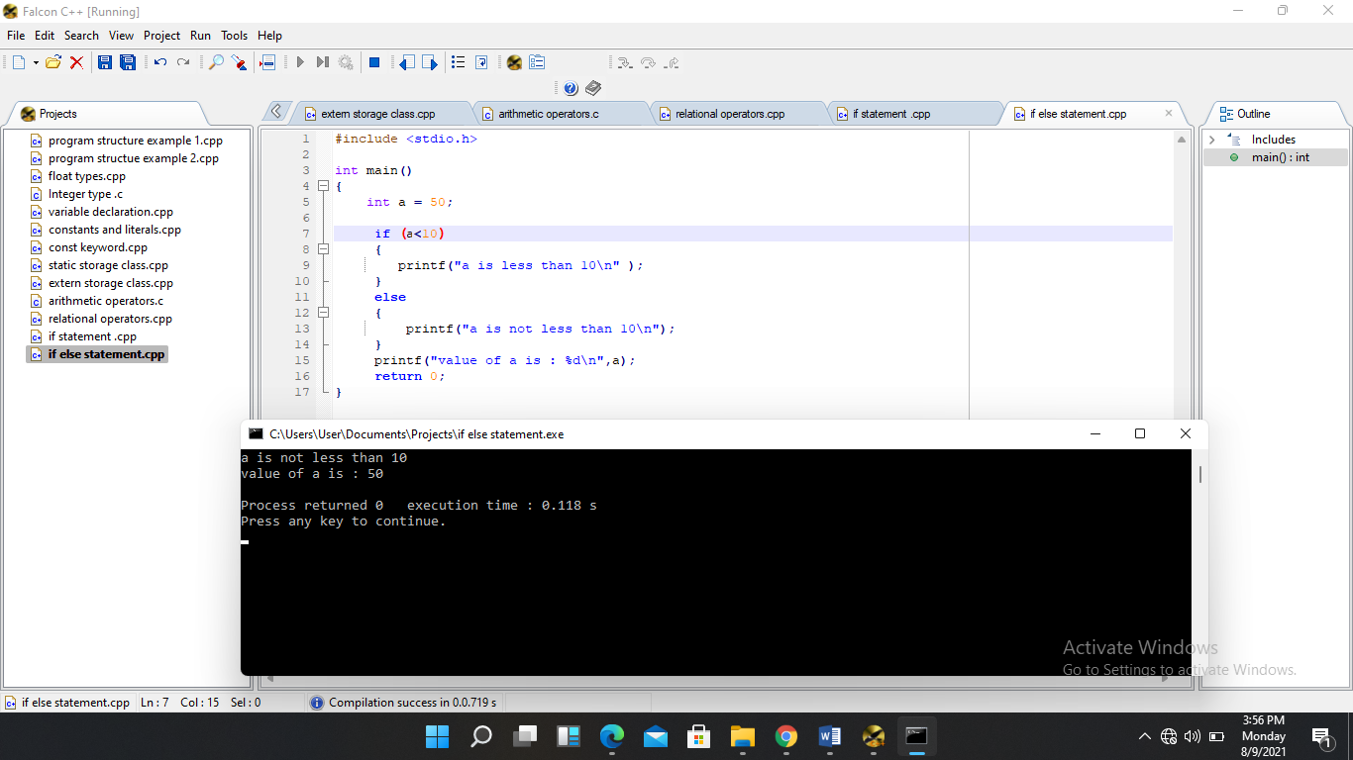

If else…..if else

example

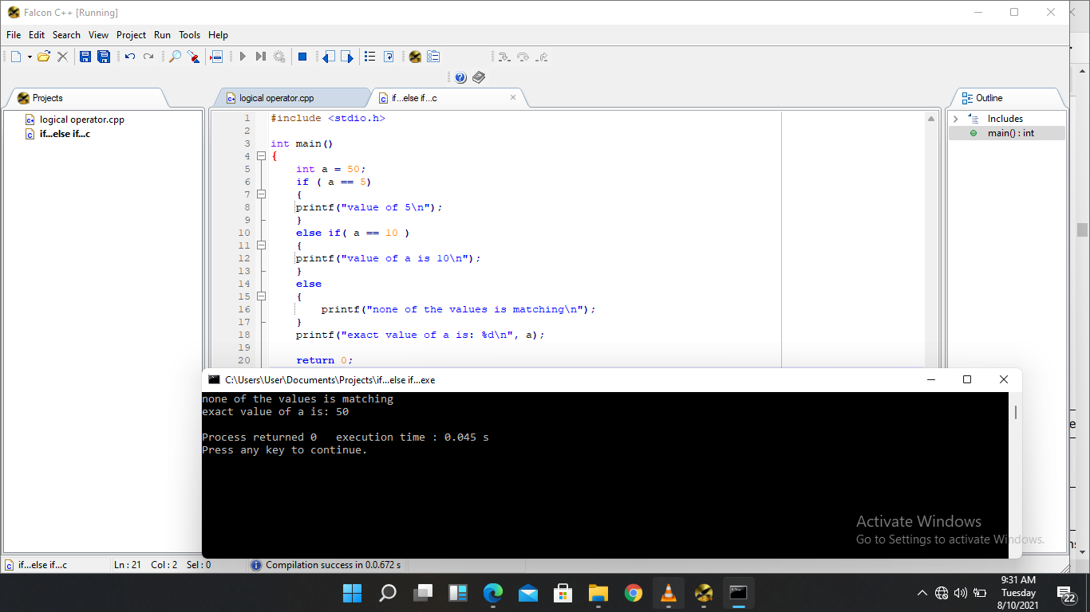

If else

Example

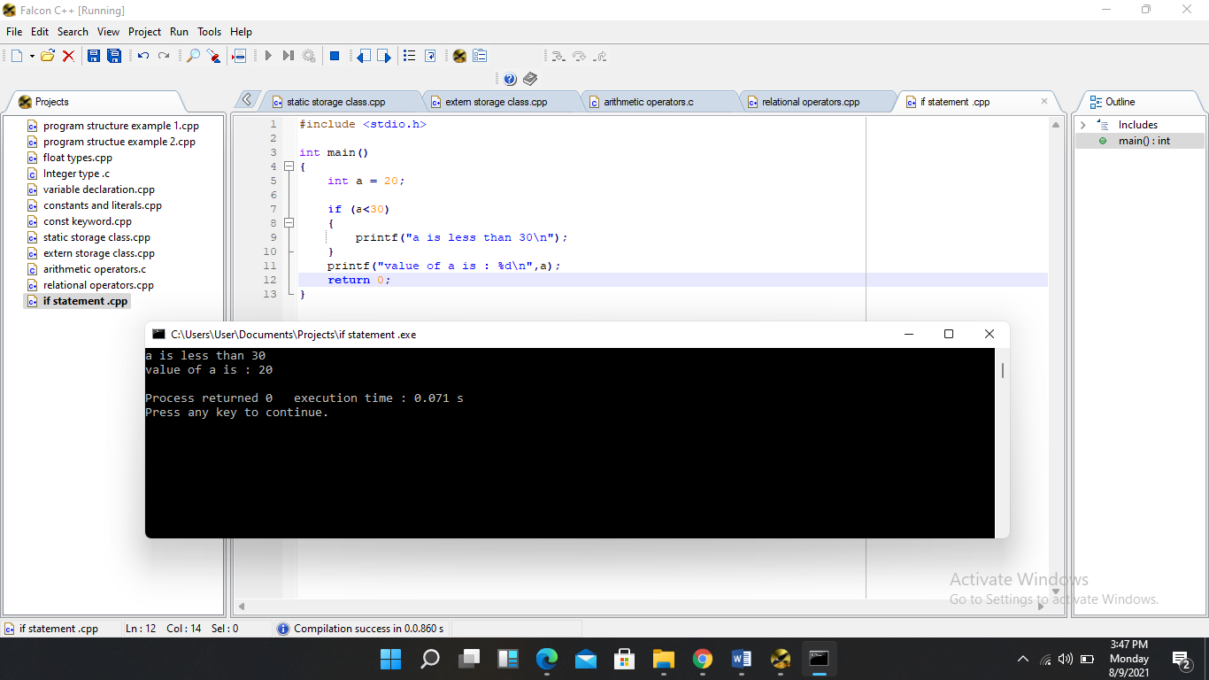

**11.Loops**

**Examples**

While loop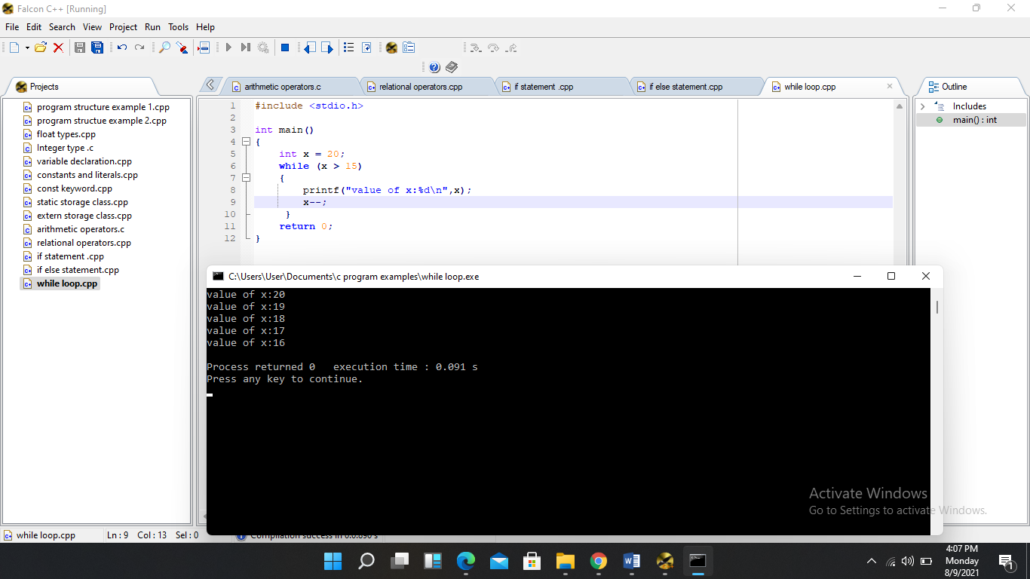

Do…while loop example

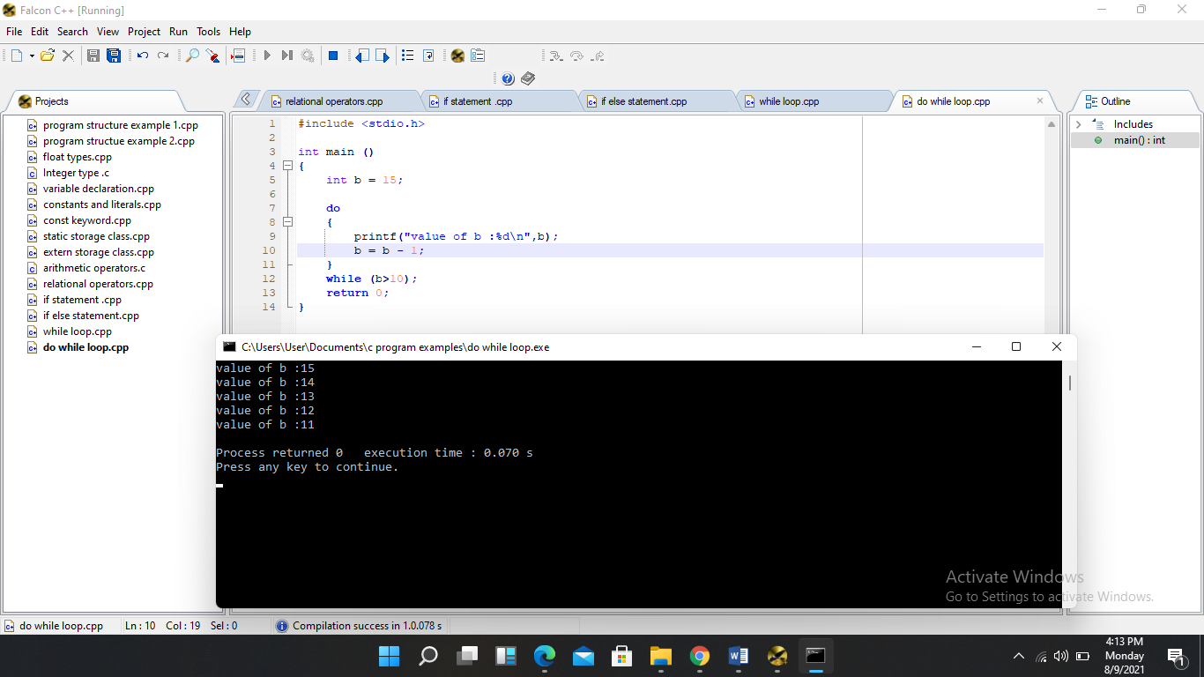

For loop example

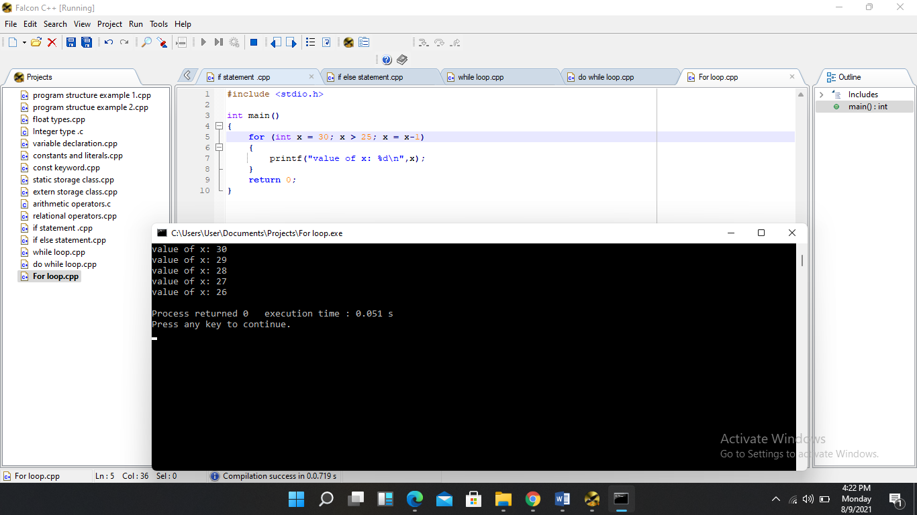

Nested for loop

Example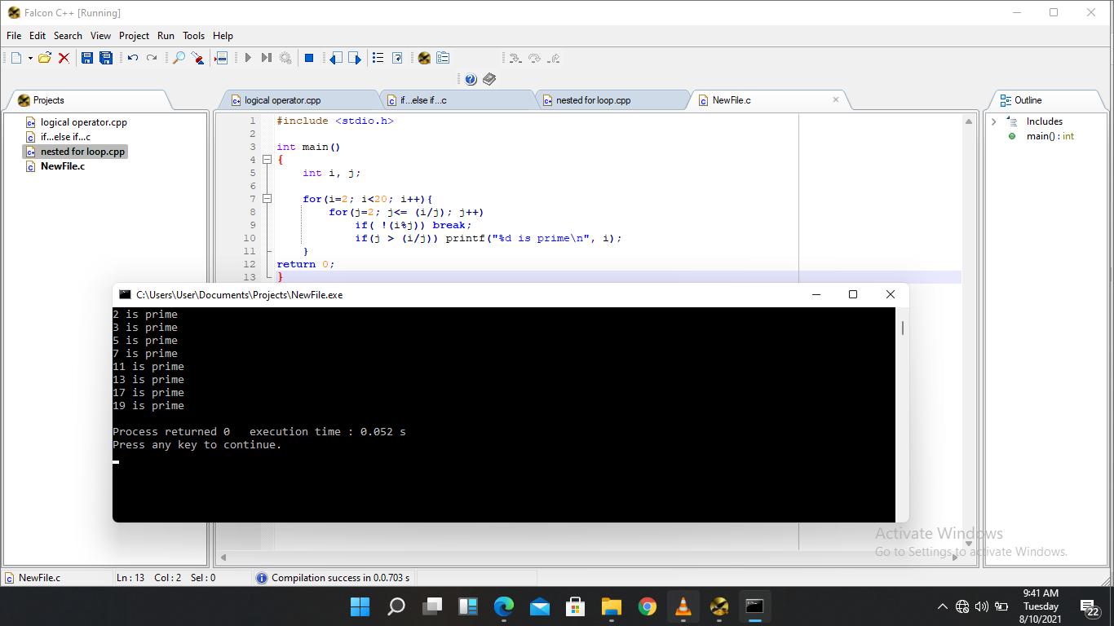

**Functions**

**Function declaration**

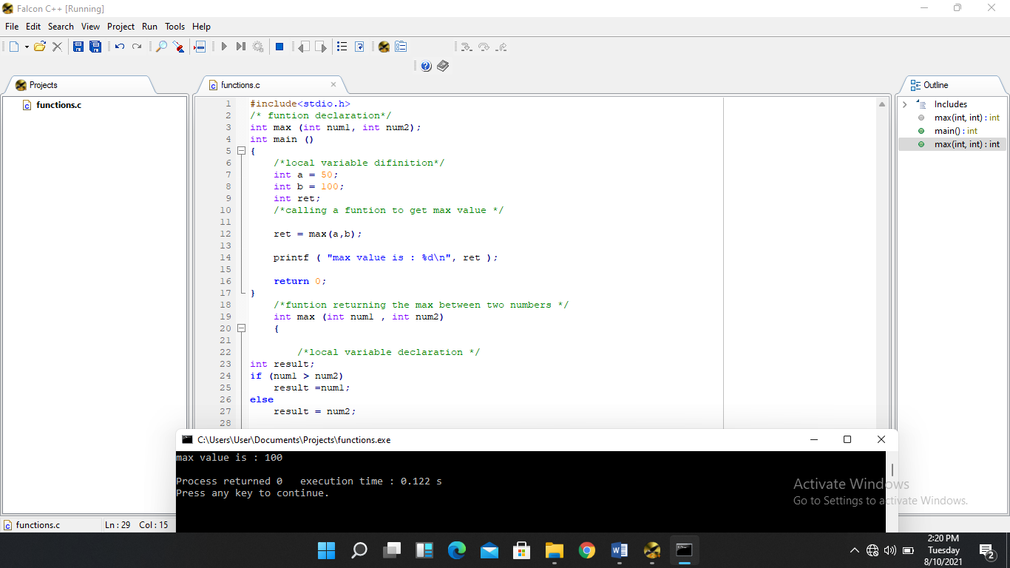

Call by value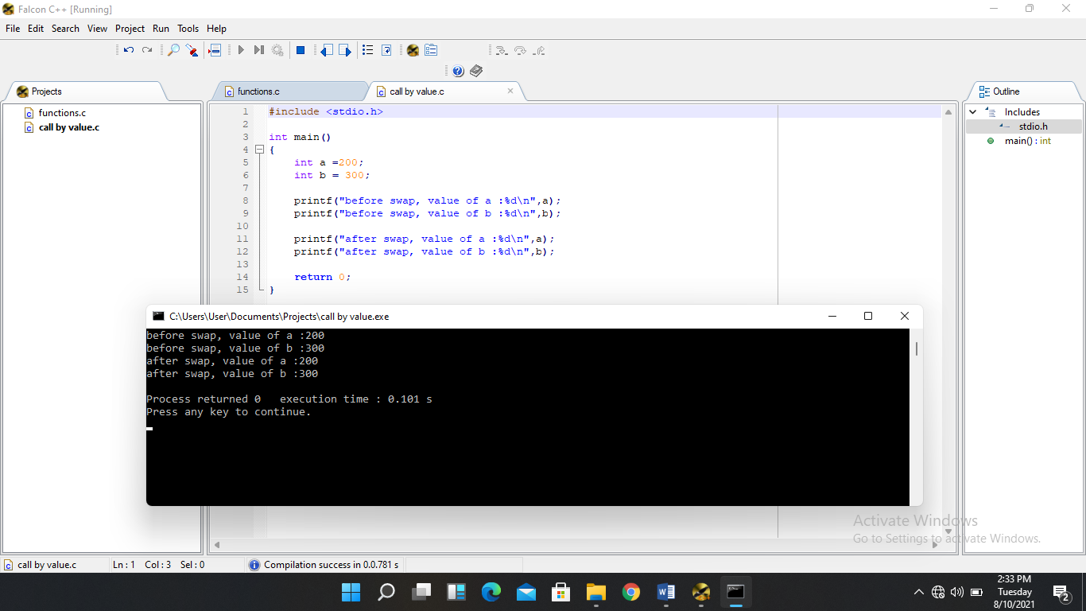

13. **Scope rule**

Local variables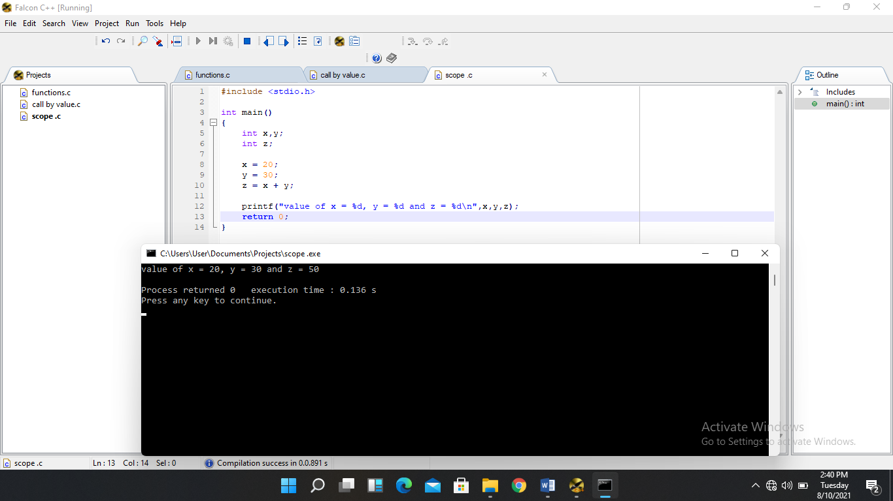

Global variables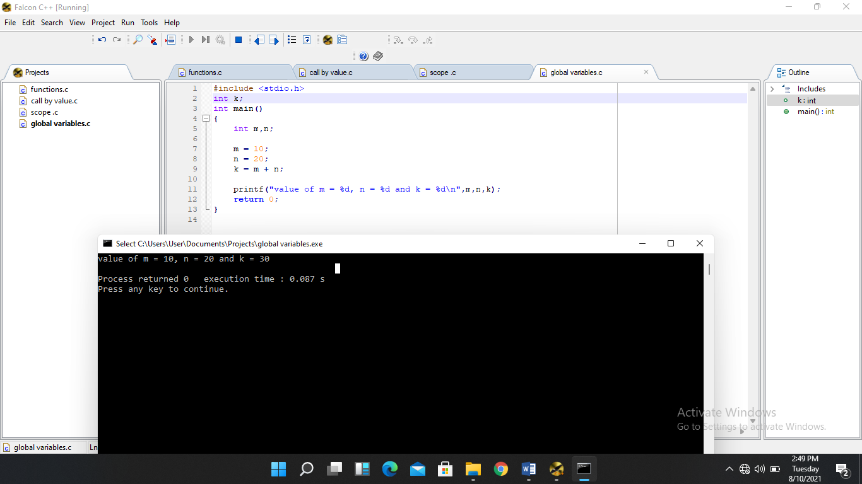

**14. Arrays**

Accessing array elements